**[ASSIGNMENT NO 7]**

**1} Write a program a Grid view**

**2} Write a program to demonstrate the insert,delete**

**&update.**

**DBDemo.aspx**

<%@ Page Language="C#" AutoEventWireup="true" CodeFile="DBDemo.aspx.cs" Inherits="DBDemo" %>

<!DOCTYPE html PUBLIC "-//W3C//DTD XHTML 1.0 Transitional//EN" "http://www.w3.org/TR/xhtml1/DTD/xhtml1-transitional.dtd">

<html xmlns="http://www.w3.org/1999/xhtml">

<head runat="server">

<title>Untitled Page</title>

</head>

<body>

<form id="form1" runat="server">

<div align="center">

&nbsp;&nbsp;

<asp:Label ID="Label4" runat="server" Font-Bold="True" Font-Size="Larger"

Text="Employee Inforamtion"></asp:Label>

<br />

<asp:GridView ID="GridView1" runat="server" AutoGenerateColumns="False"

DataSourceID="SqlDataSourceEmployee" BackColor="#DEBA84"

BorderColor="#DEBA84" BorderStyle="None" BorderWidth="1px" CellPadding="3"

CellSpacing="2" Width="327px">

<RowStyle BackColor="#FFF7E7" ForeColor="#8C4510" />

<Columns>

<asp:BoundField DataField="name" HeaderText="name" SortExpression="name" />

<asp:BoundField DataField="address" HeaderText="address"

SortExpression="address" />

<asp:BoundField DataField="sal" HeaderText="sal" SortExpression="sal" />

</Columns>

<FooterStyle BackColor="#F7DFB5" ForeColor="#8C4510" />

<PagerStyle ForeColor="#8C4510" HorizontalAlign="Center" />

<SelectedRowStyle BackColor="#738A9C" Font-Bold="True" ForeColor="White" />

<HeaderStyle BackColor="#A55129" Font-Bold="True" ForeColor="White" />

</asp:GridView>

<asp:SqlDataSource ID="SqlDataSourceEmployee" runat="server"

ConnectionString="<%$ ConnectionStrings:ConnectionStringEmp %>"

SelectCommand="SELECT * FROM [emp]"></asp:SqlDataSource>

<asp:Label ID="Label1" runat="server" Text="Name"></asp:Label>

<asp:TextBox ID="TextBox1" runat="server"></asp:TextBox>

<br />

<asp:Label ID="Label2" runat="server" Text="Address"></asp:Label>

<asp:TextBox ID="TextBox2" runat="server"></asp:TextBox>

<br />

<asp:Label ID="Label3" runat="server" Text="Salary"></asp:Label>

<asp:TextBox ID="TextBox3" runat="server"></asp:TextBox>

<br />

<asp:Button ID="Button1" runat="server" onclick="Button1_Click" Text="Save"

style="font-weight: 700" />

<asp:Button ID="Button2" runat="server" onclick="Button2_Click" Text="Update"

style="font-weight: 700" />

<asp:Button ID="Button3" runat="server" Text="Delete" onclick="Button3_Click"

style="font-weight: 700" />

<asp:Button ID="Button4" runat="server" onclick="Button4_Click"

style="font-weight: 700" Text="Cancel" />

<br />

</div>

</form>

</body>

</html>

**DBDemo.aspx.cs**

using System;

using System.Collections;

using System.Configuration;

using System.Data;

using System.Linq;

using System.Web;

using System.Web.Security;

using System.Web.UI;

using System.Web.UI.HtmlControls;

using System.Web.UI.WebControls;

using System.Web.UI.WebControls.WebParts;

using System.Xml.Linq;

using System.Data.SqlClient;

public partial class DBDemo : System.Web.UI.Page

{

SqlConnection con = new SqlConnection("Data Source=.\\SQLEXPRESS;AttachDbFilename='D:\\RBP\\VP Programs\\App_Data\\Database1.mdf';Integrated Security=True;User Instance=True");

protected void Page_Load(object sender, EventArgs e)

{

con.Open();

}

protected void Button1_Click(object sender, EventArgs e)

{

SqlCommand cmd = con.CreateCommand();

cmd.CommandType = CommandType.Text;

cmd.CommandText = "insert into emp values('"+TextBox1.Text +"','"+TextBox2.Text +"',"+Int32.Parse(TextBox3.Text) +")";

cmd.ExecuteNonQuery();

Response.Redirect("~/DBDemo.aspx");

con.Close();

}

protected void Button2_Click(object sender, EventArgs e)

{

SqlCommand cmd = con.CreateCommand();

cmd.CommandType = CommandType.Text;

cmd.CommandText = "update emp set address='"+TextBox2.Text + "', sal=" + Int32.Parse(TextBox3.Text) + " where name='"+TextBox1.Text+"'" ;

cmd.ExecuteNonQuery();

Response.Redirect("~/DBDemo.aspx");

con.Close();

}

protected void Button3_Click(object sender, EventArgs e)

{

SqlCommand cmd = con.CreateCommand();

cmd.CommandType = CommandType.Text;

cmd.CommandText = "delete from emp where name='"+TextBox1.Text +"'";

cmd.ExecuteNonQuery();

Response.Redirect("~/DBDemo.aspx");

con.Close();

}

protected void Button4_Click(object sender, EventArgs e)

{

TextBox1.Text = "";

TextBox2.Text = "";

TextBox3.Text = "";

}

}

**First Time run, Output is-**

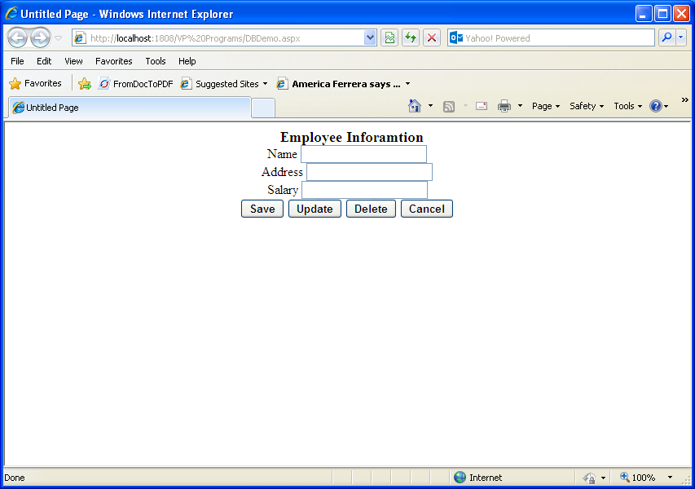

**After Inserting Data-**

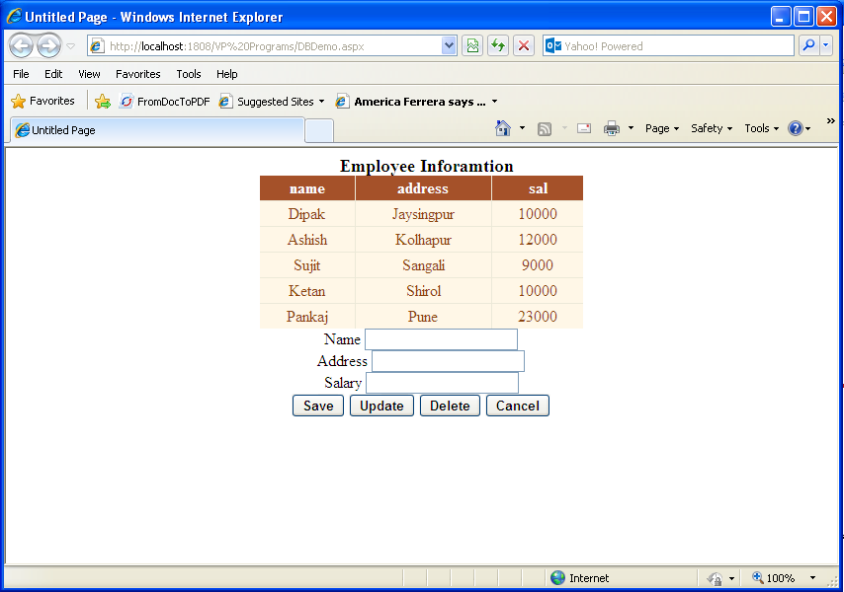

**After Updating Data-**

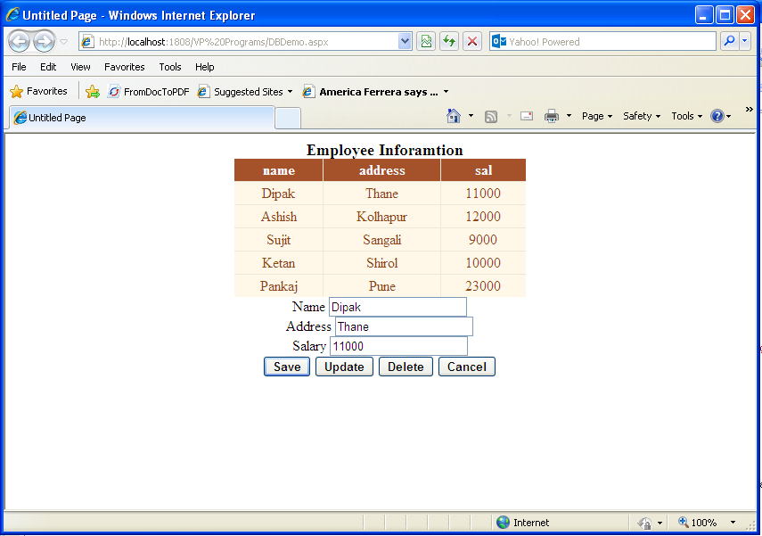

**After Deleting the data-**

